**CN5006 Lab Session Week 1 Portfolio**

Prepared by:Hiroj Bhattarai  
Date: 01-oct-2024

**Introduction**

This portfolio outlines my activities with Lab Session Week 1, guided by Dr. Nadeem Qazi. The primary objective was to set up a JavaScript development environment, write basic JavaScript programs, and familiarize myself with Visual Studio Code and Node.js.

**Step-by-Step Implementation**

**1. Installation and Setup**

* **Installed Software:**
  + **Visual Studio Code**
  + **Node.js**

**2. Verification of Node.js Installation:**  
I used the command node -v to verify the Node.js version, confirming the installation was successful. Below is the screenshot of the terminal output:

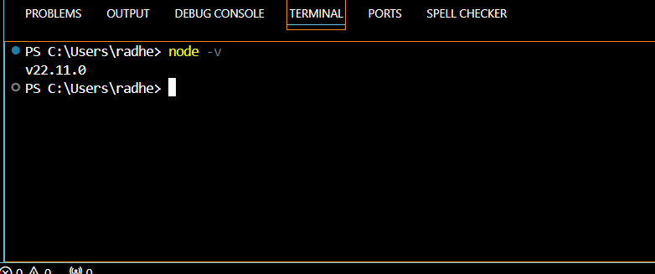

Then after I created java script file named as index.js and set the language to JavaScript and saved the file.

Step 3: writing a running java script code:

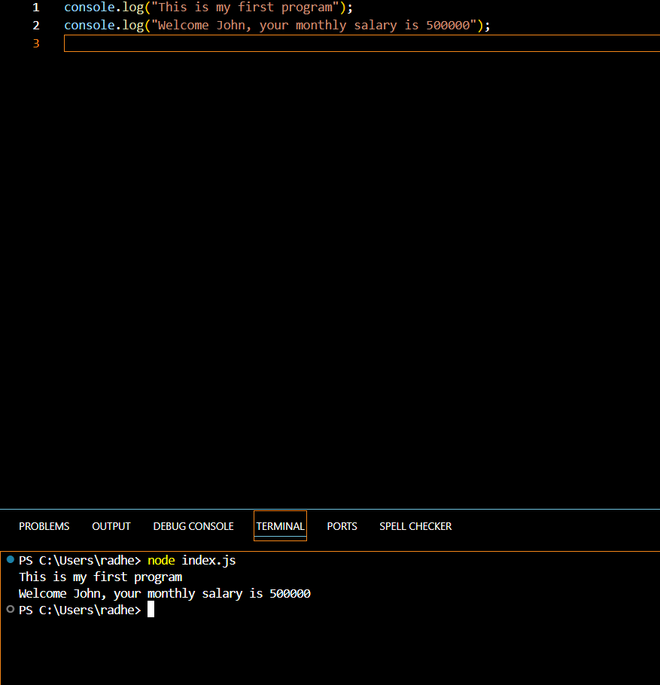

Here is the screenshot of code to calculate the console.

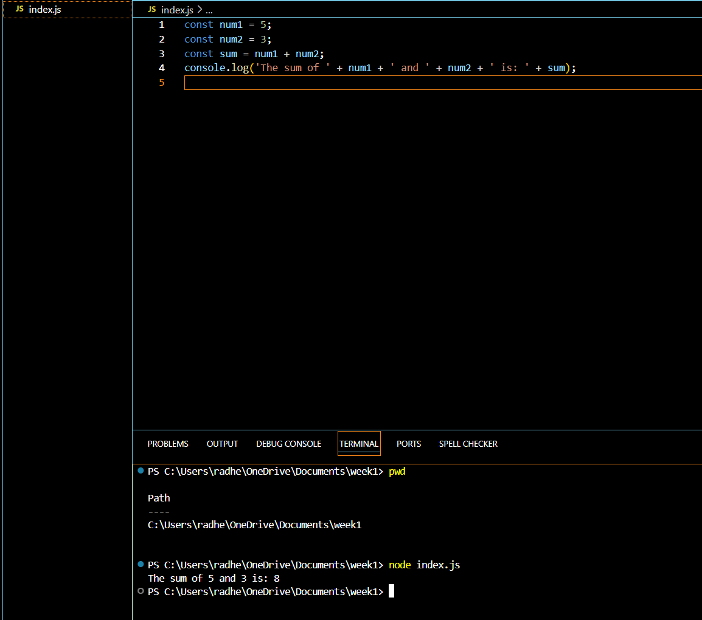

Javascript Program to Check if a number is Positive, Negative, or Zero Write the following program in the index.js

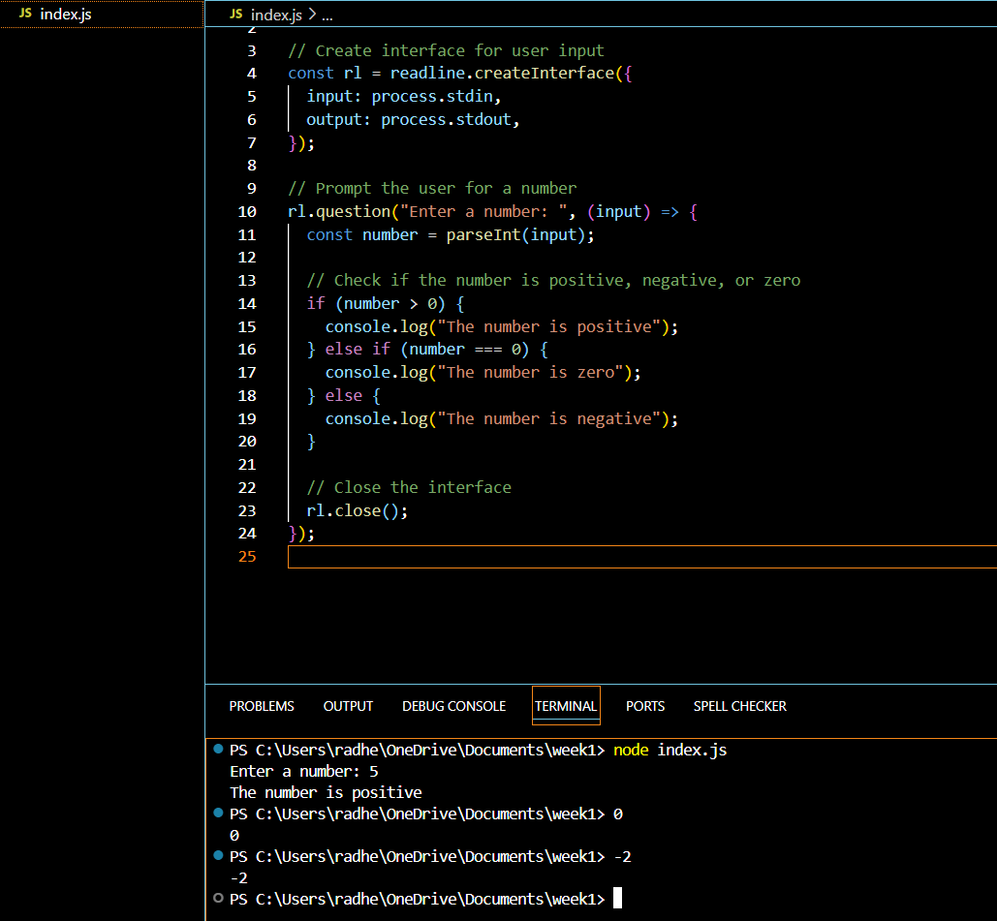

**Explanation:**  
The program checks the value of a user-input number and uses if-else statements to determine whether it is positive, zero, or negative. The prompt() function collects user input (use a compatible environment or substitute for testing).

**Portfolio Exercise: Multi-operation Calculator:**

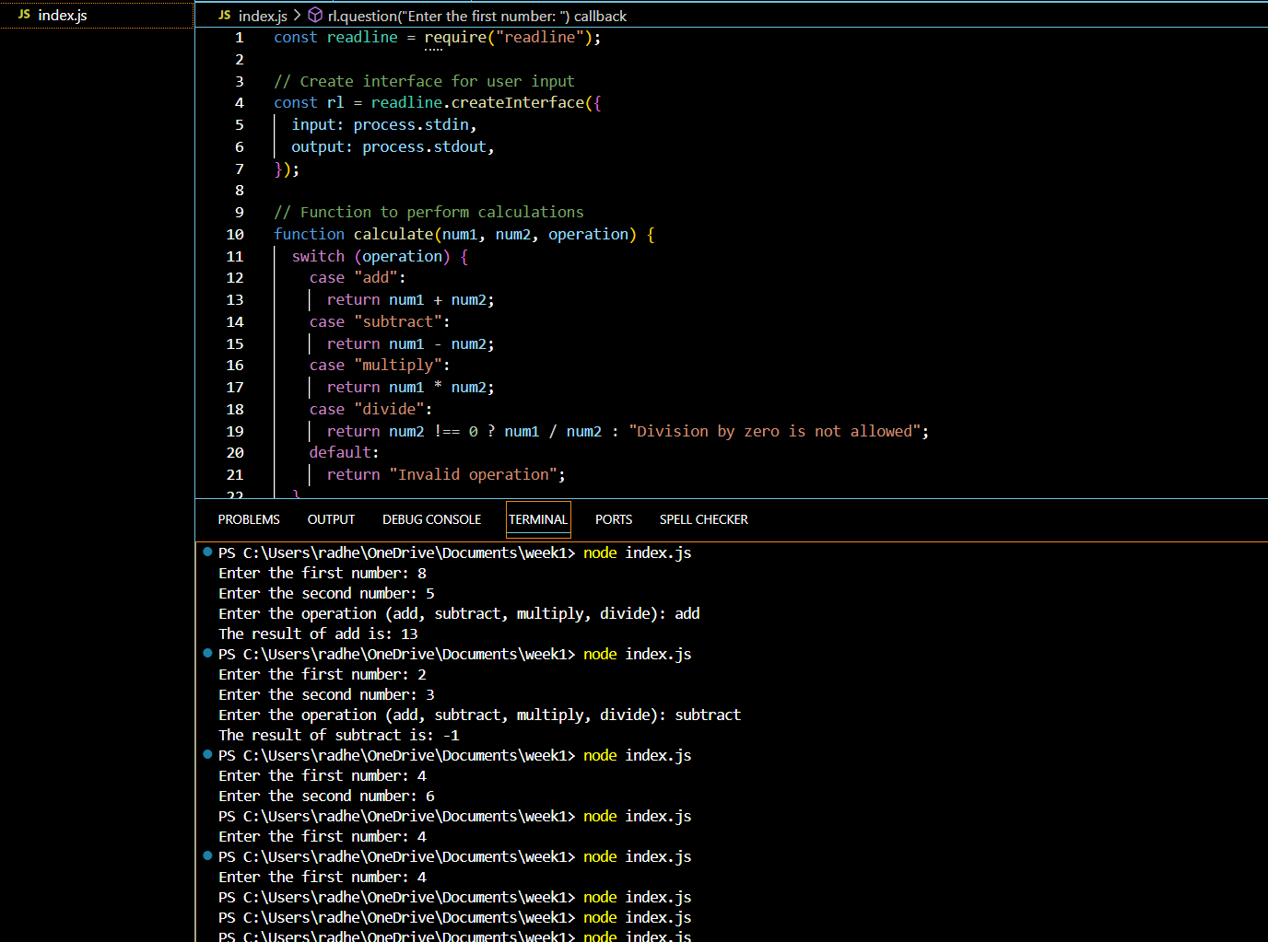

**Explanation:**This program demonstrates how to perform multiple arithmetic operations using a switch statement. It dynamically selects the operation based on the input.

**Conclusion for Portfolio Exercise**

The portfolio exercise offered hands-on experience to apply fundamental JavaScript concepts such as functions, user input handling, conditional statements, and switch cases. By creating a calculator program.

**Reflection:**

My comprehension of how JavaScript is used to construct interactive programs has improved as a result of this exercise. My ability to think logically and solve problems was enhanced by the difficulties I encountered when debugging errors, such as handling division by zero. My confidence in using JavaScript for backend development increased after writing the code and witnessing its successful execution.  
  
Working in the Node.js environment also gave me a better understanding of how JavaScript works outside of the browser, which is important for creating full-stack applications. All things considered, this exercise was a useful step in my learning process to become an expert in developing web and mobile applications.

**Harvard style reference:**

Microsoft, 2024. *Visual Studio Code: Documentation*. [online] Available at: <https://code.visualstudio.com/docs> [Accessed 23 November 2024].

Node.js, 2024. *Node.js Documentation*. [online] Available at: https://nodejs.org/en/docs/ [Accessed 23 November 2024].

Qazi, N., 2024. *CN5006 Lab Session Week 1 Tutorial*. University of Greenwich.

Mozilla, 2024. *JavaScript Guide*. [online] Available at: <https://developer.mozilla.org/en-US/docs/Web/JavaScript/Guide> [Accessed 23 November 2024].

University of Greenwich, 2024. *Moodle: CN5006 Web and Mobile Application Development*. [online] Available at: https://moodle.greenwich.ac.uk/ [Accessed 23 November 2024].